Chef

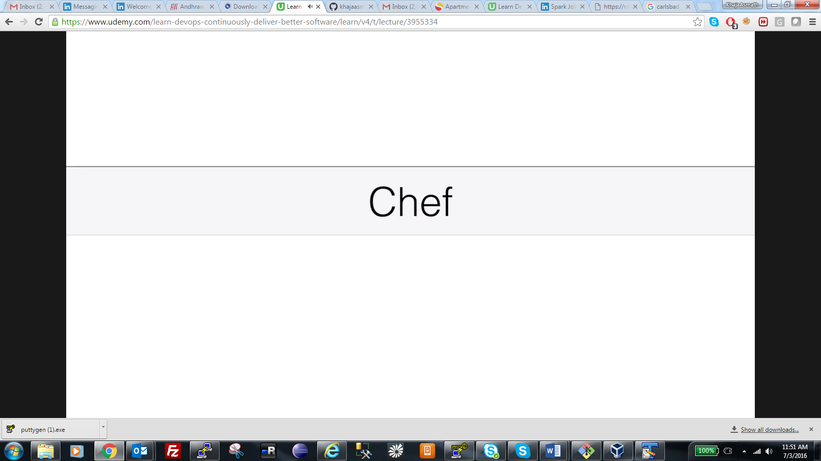

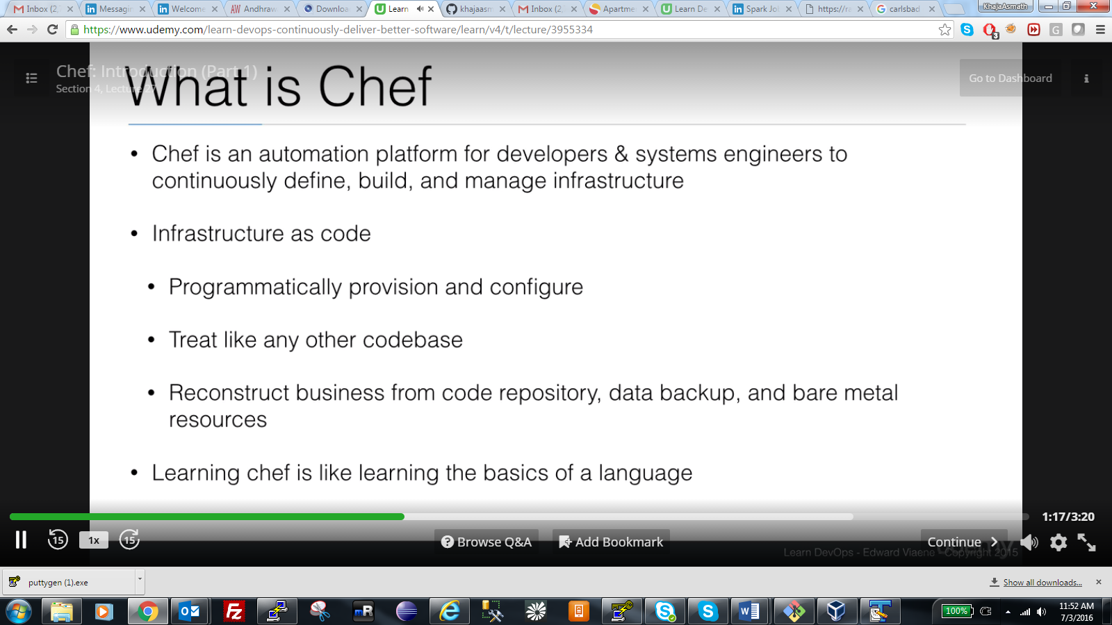

Infrastructure as code. You write code for infrastructure and use chef as automation tool for continuously build the project.

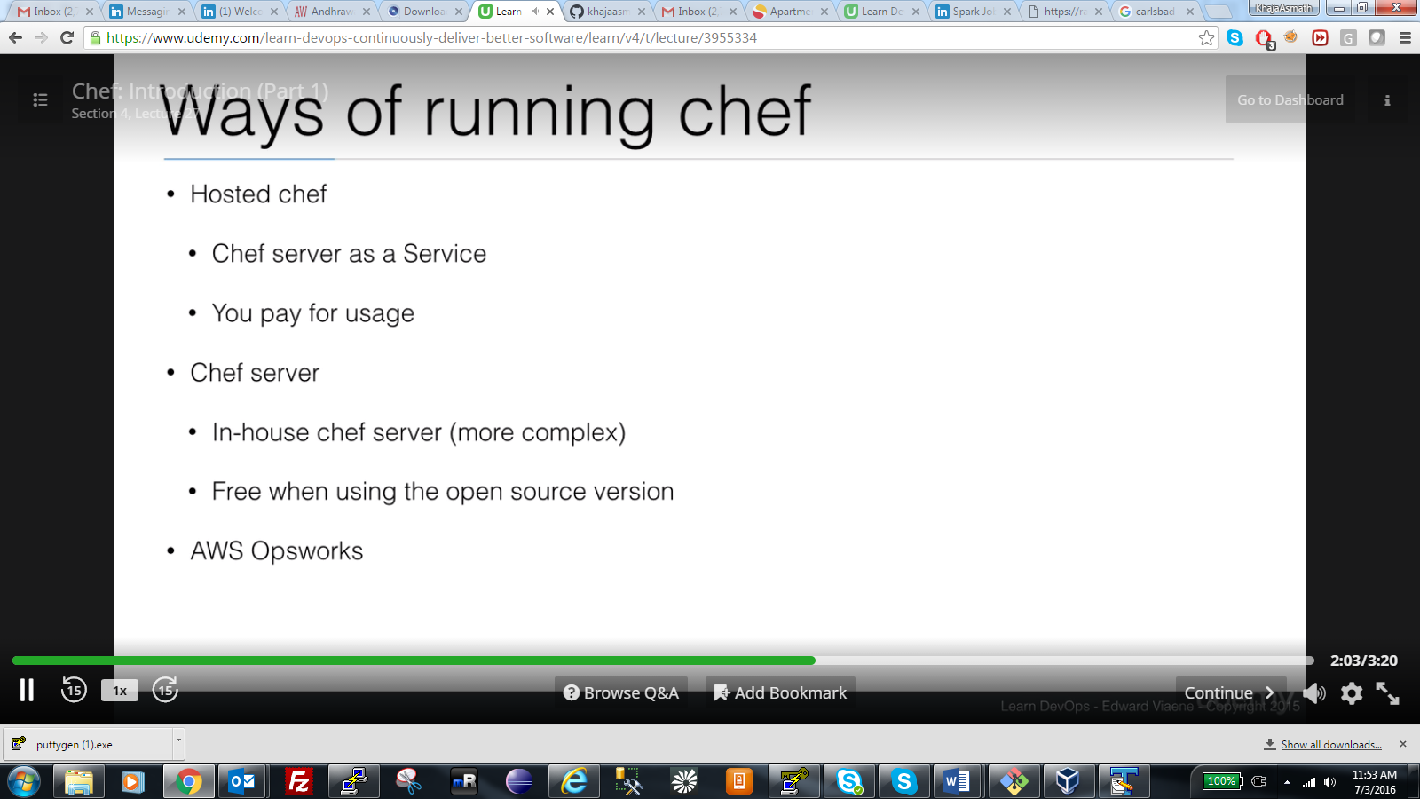

Hosted chef pay as you use, chef server.

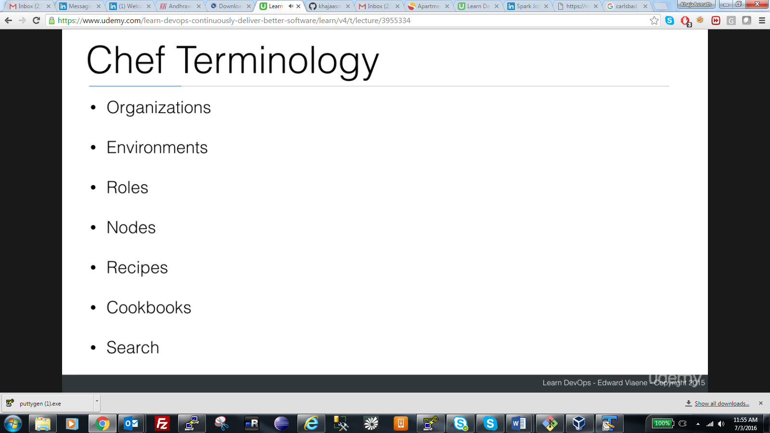

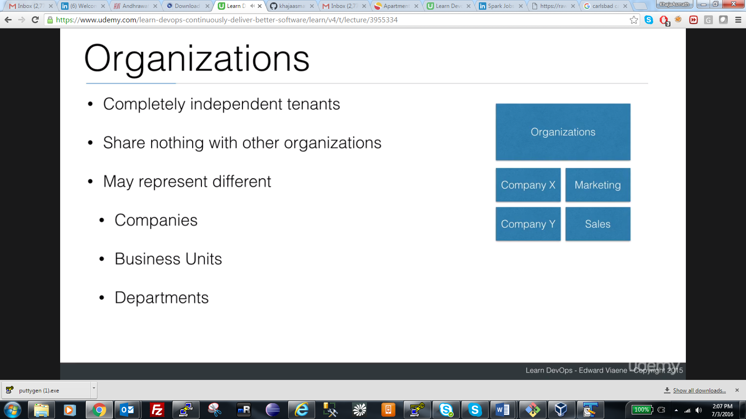

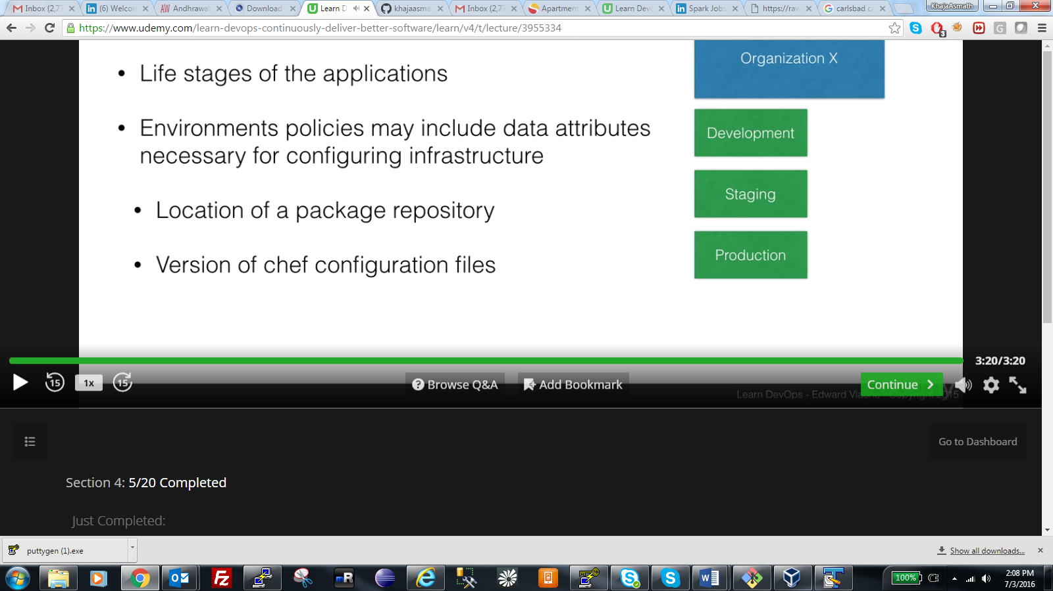

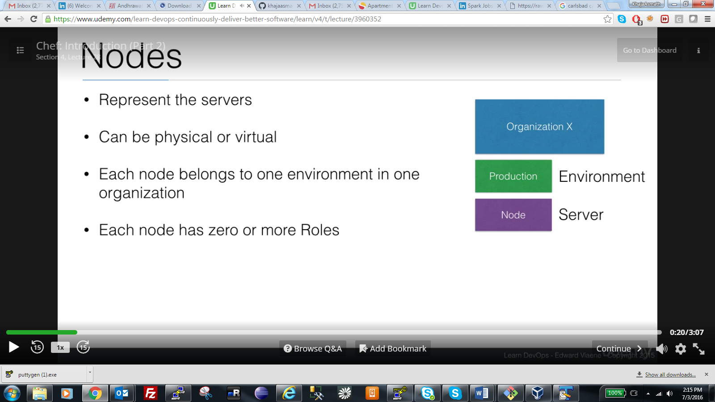

Same node cannot be used for dev and production.

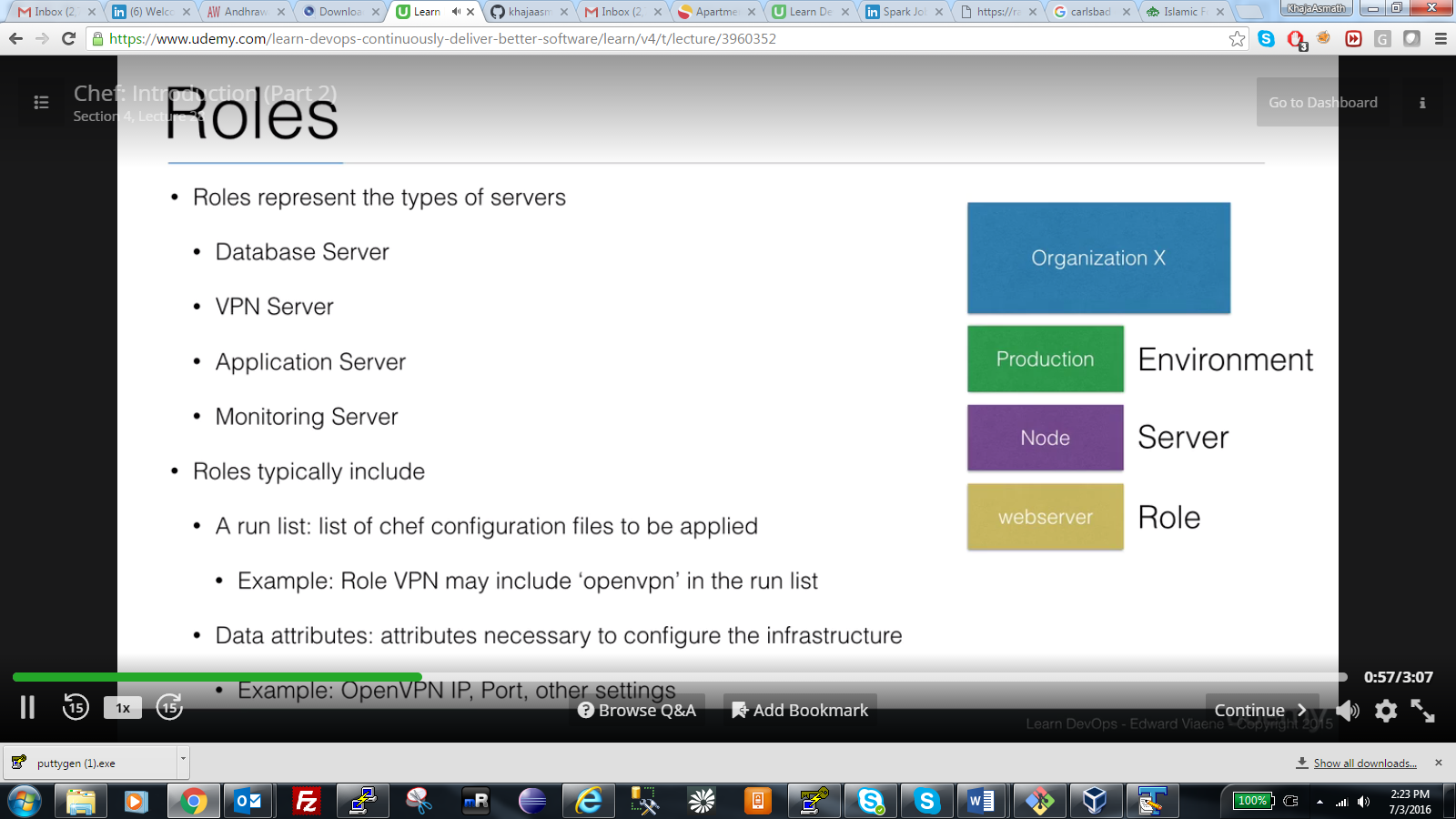

Roles is type of server and also list of configuration files.

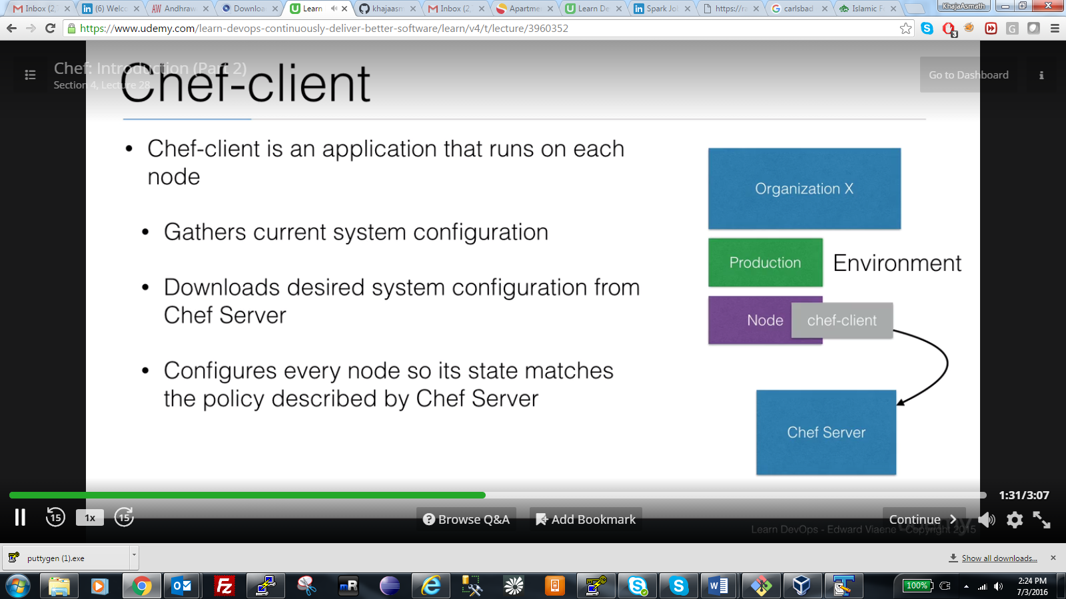

Chef client on each node (right side) and gathers information from chef server for every 30 min as default.

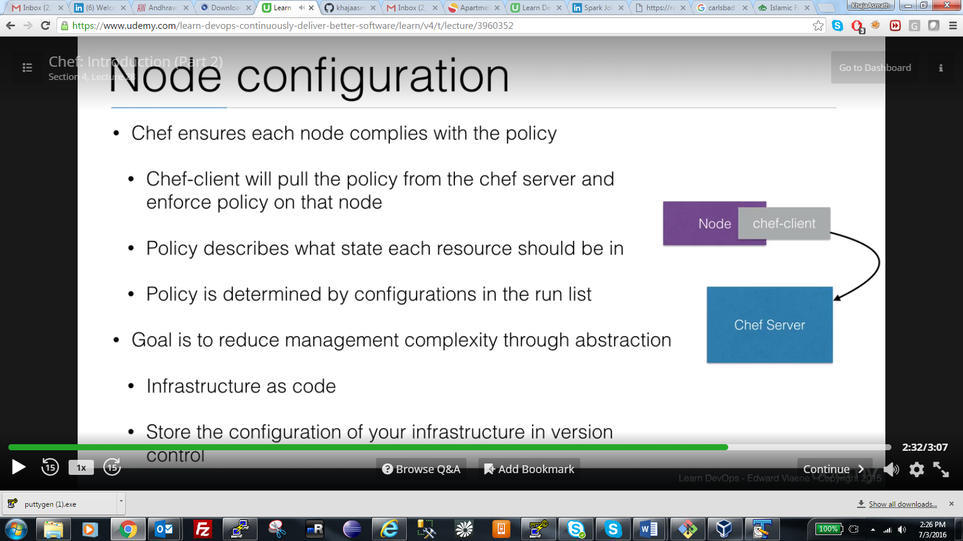



Resources are like programs , cron job etc

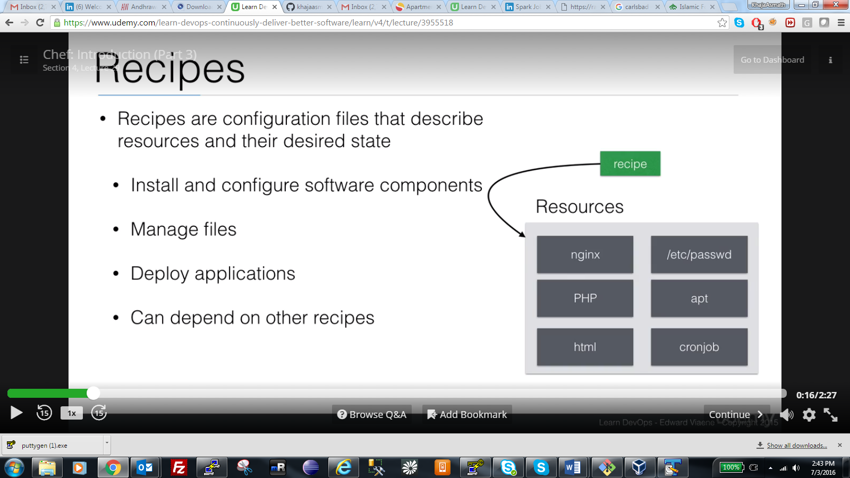

Recipes are configuration files that let to run the resources.

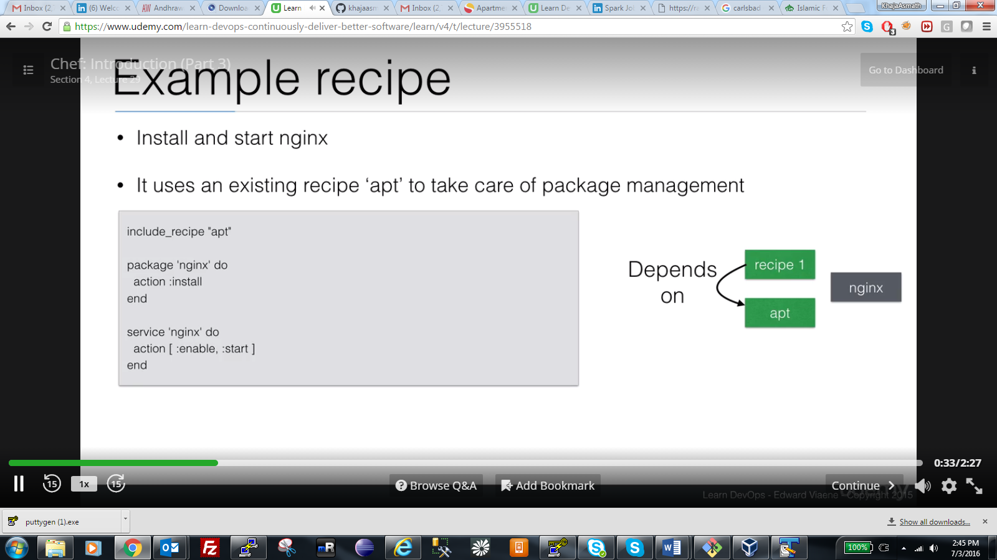

Receipe is configuration file . configuration file to install and start programs. See right side

Include receipe, package to action .. this is installing package and then service is to start the action.

Receipes are stored in cookbook.

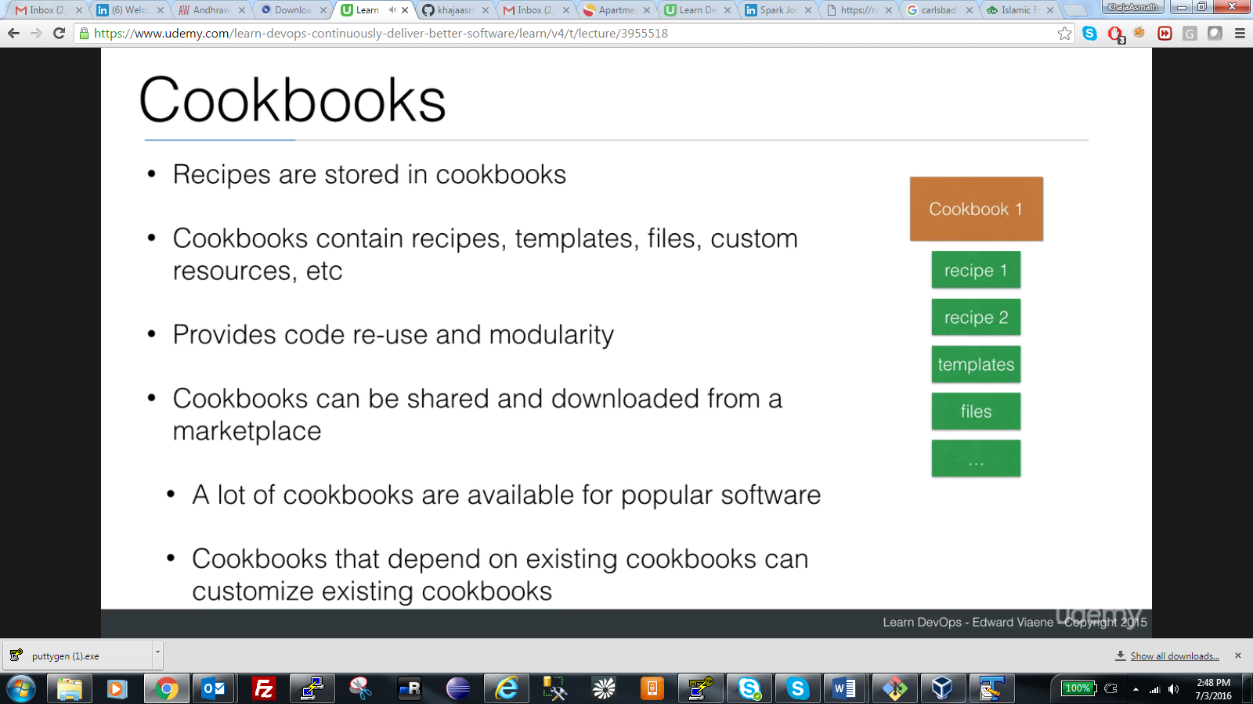

Cookbook contains recipes. Most of ones can be downloaded from market place.

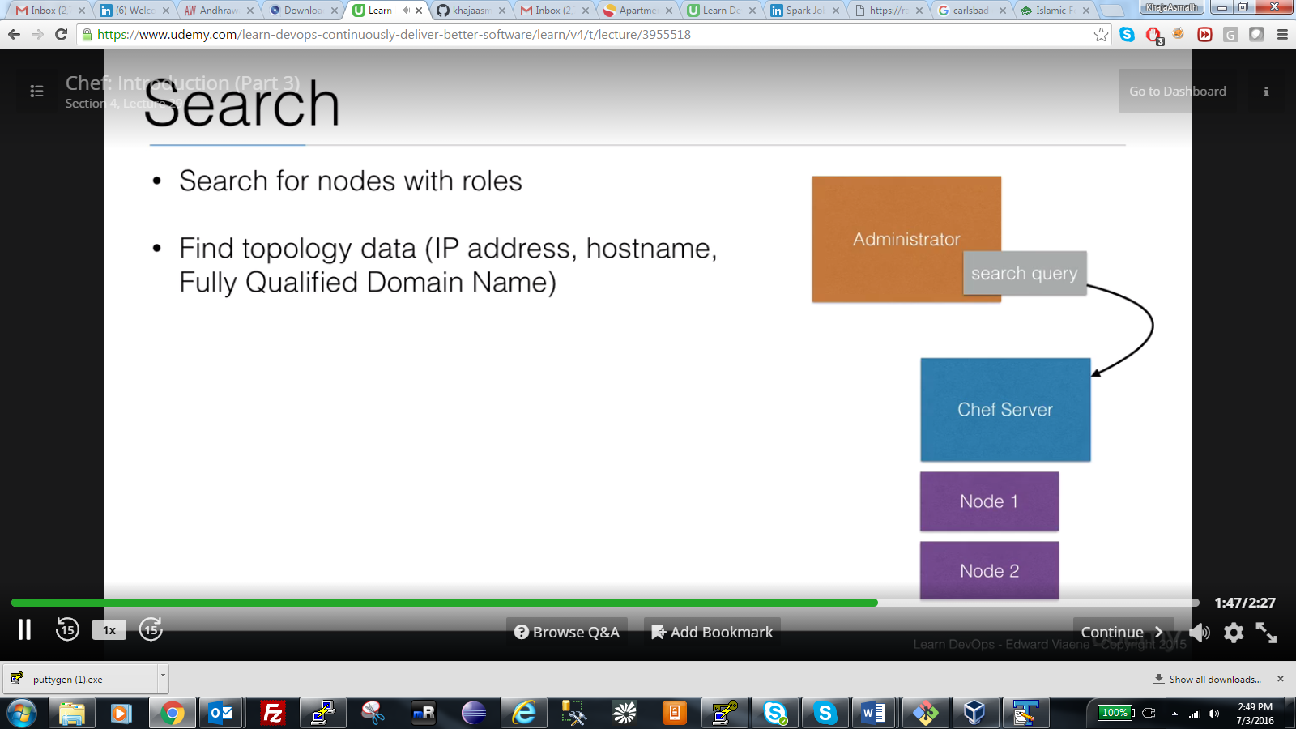

Nodes will store the information iside database.

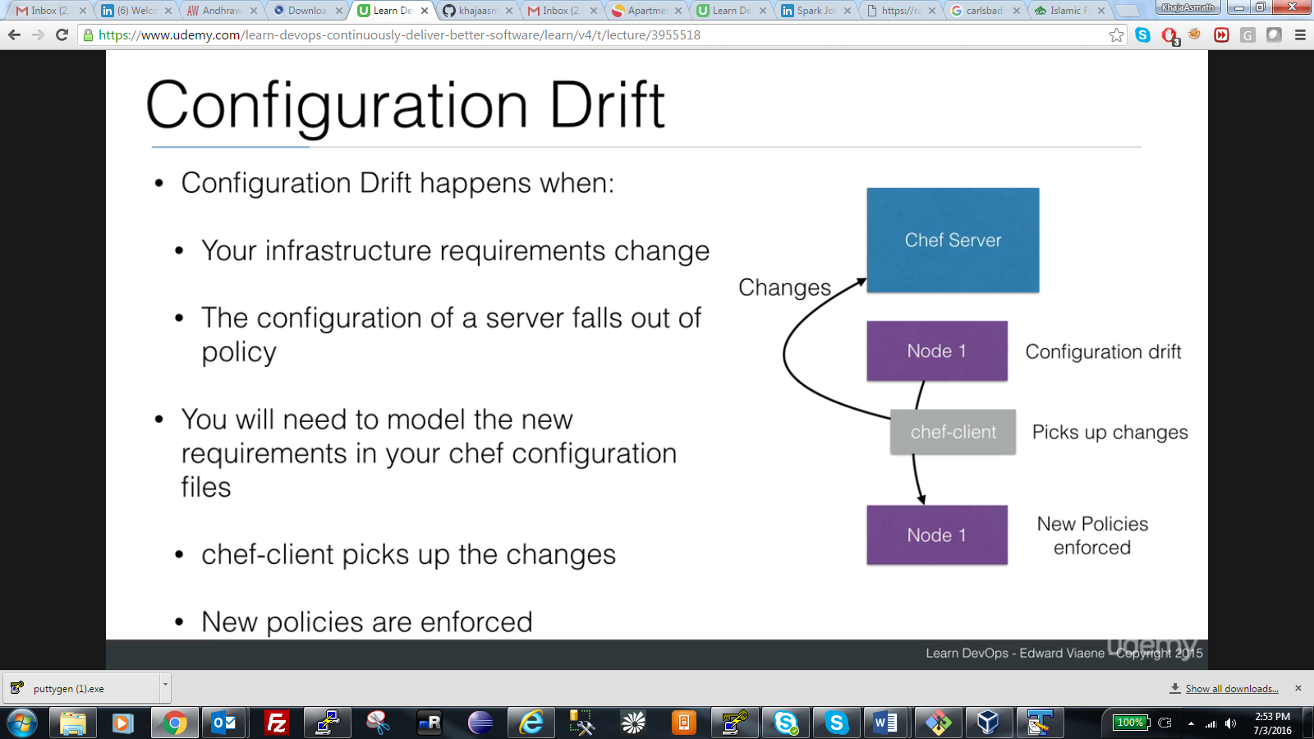

Happens when infrastructure changes happen, configuration of server will aslo chane at this time. You need to update the configuration changes too, chef client pics up those from chef server and applies to the nodes.

Nodes on server which are applied by chef client on chef server. In above, node1 are on server.

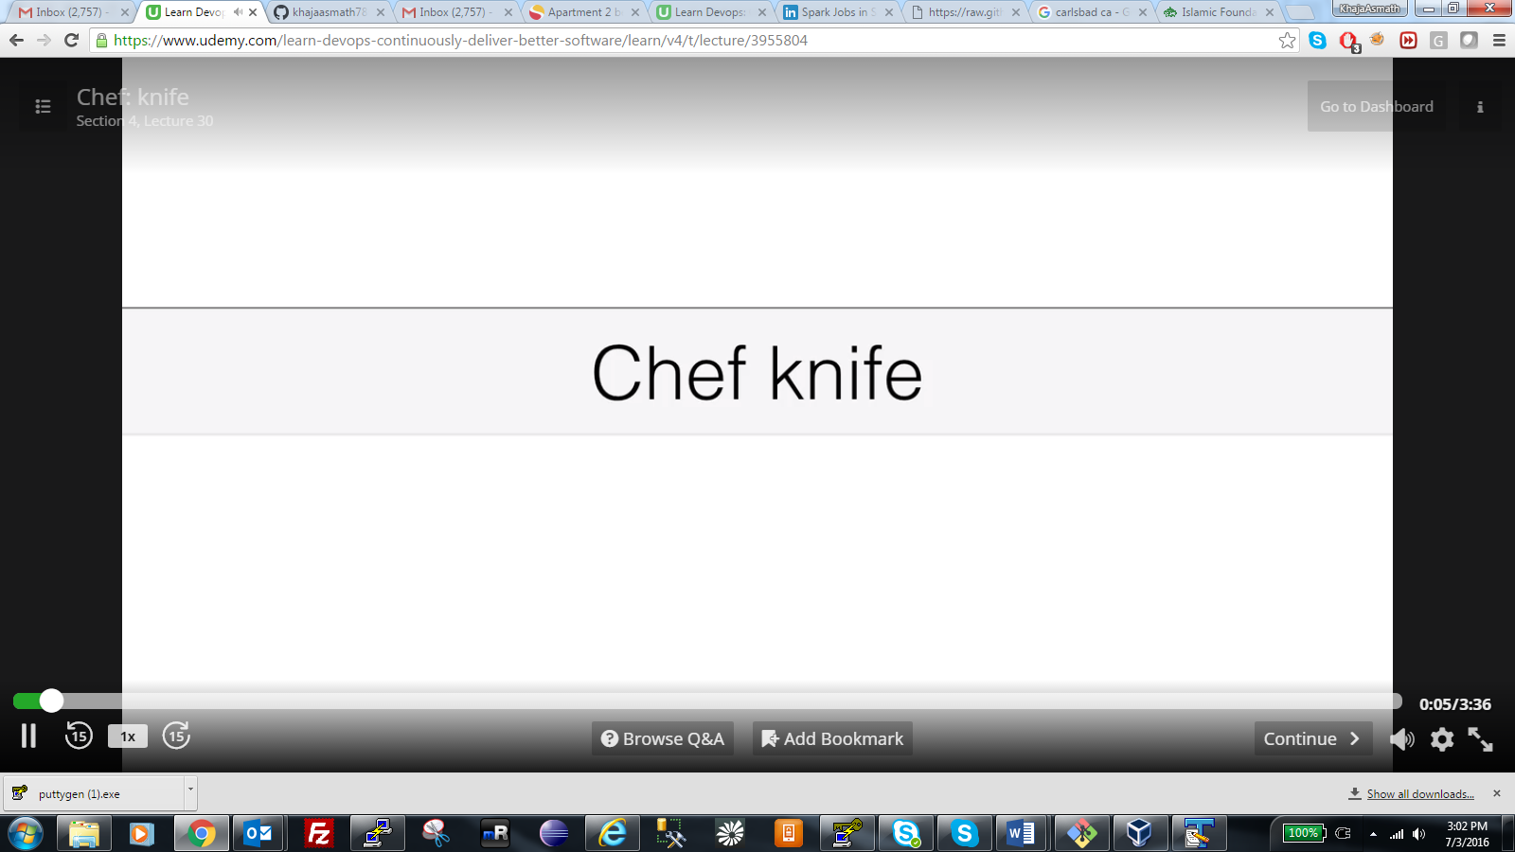

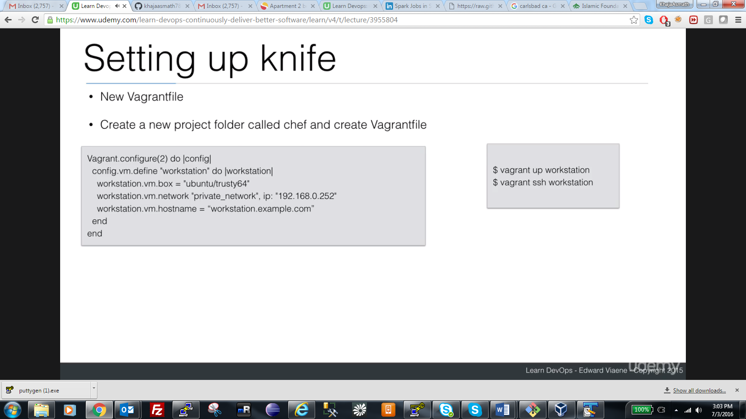

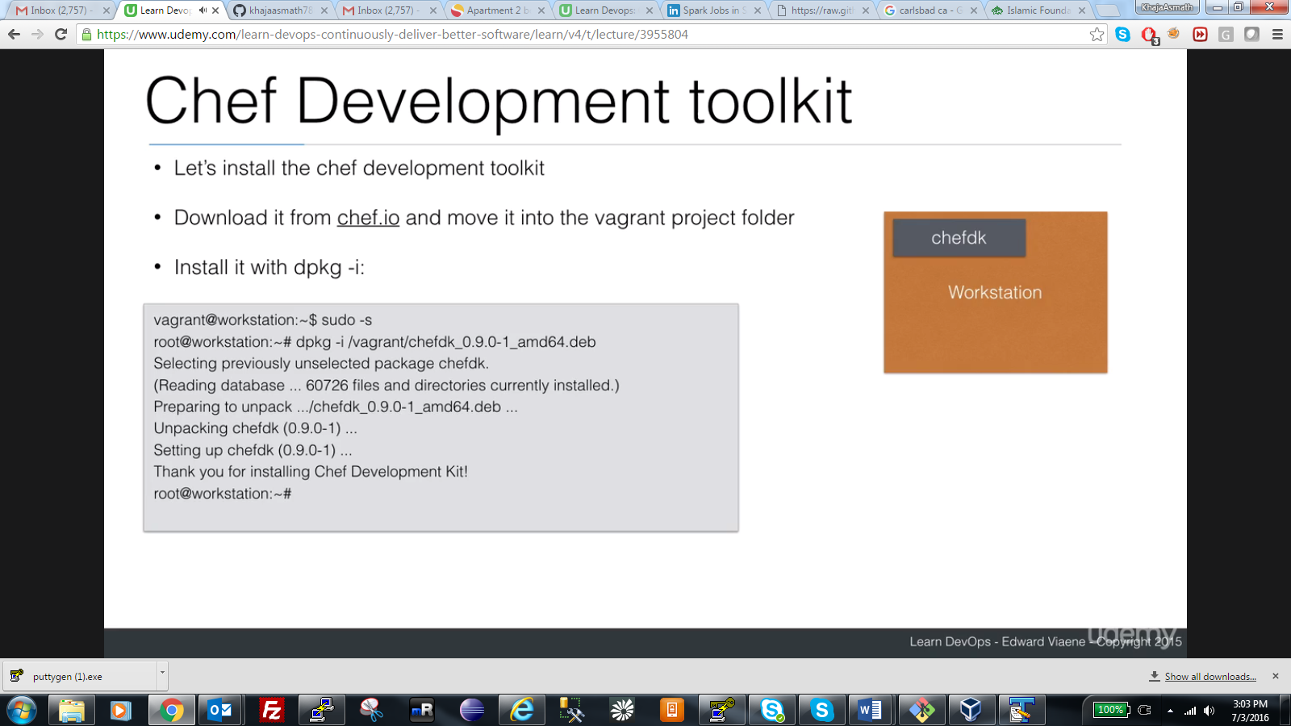

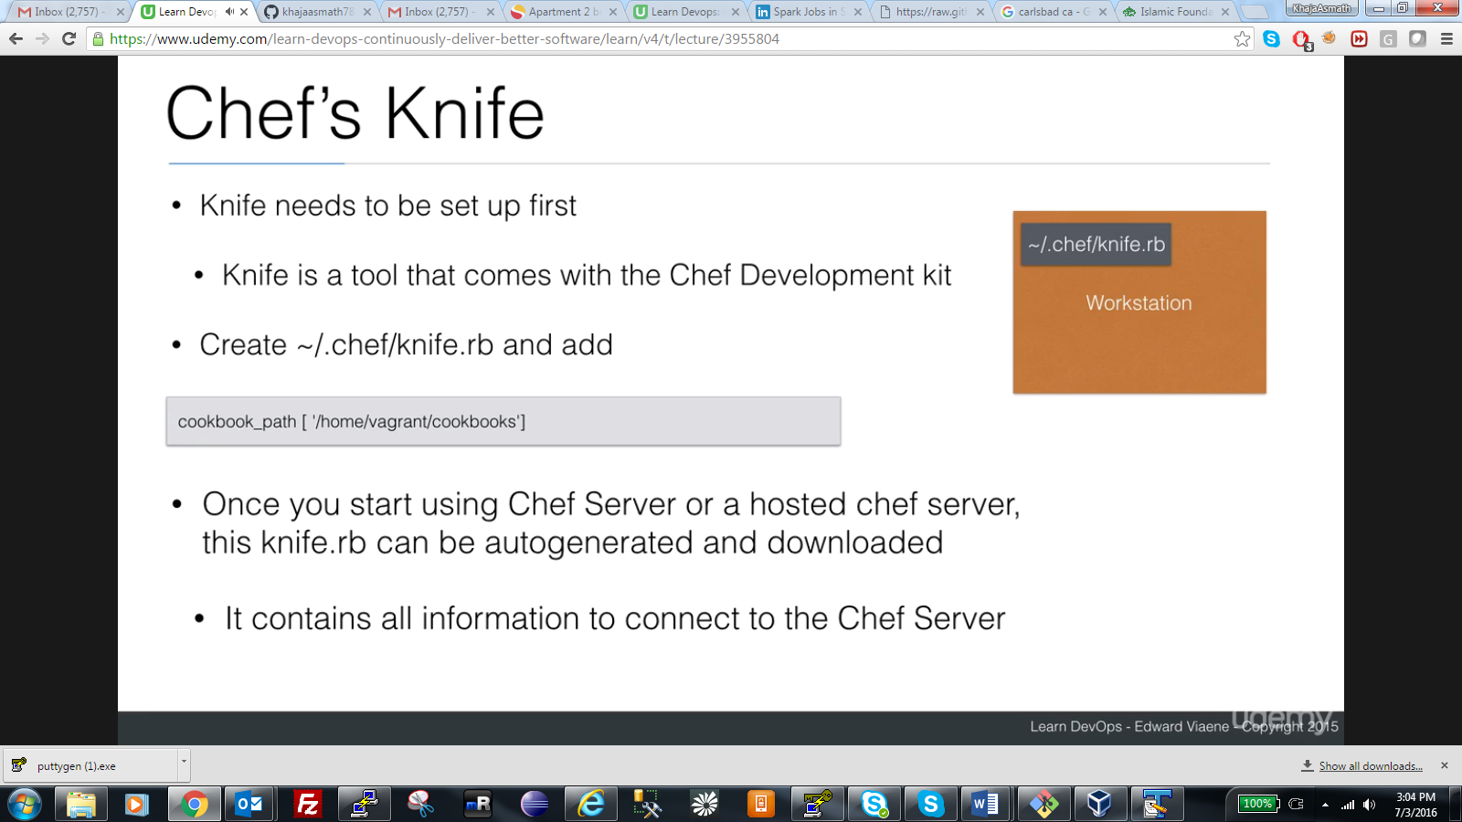

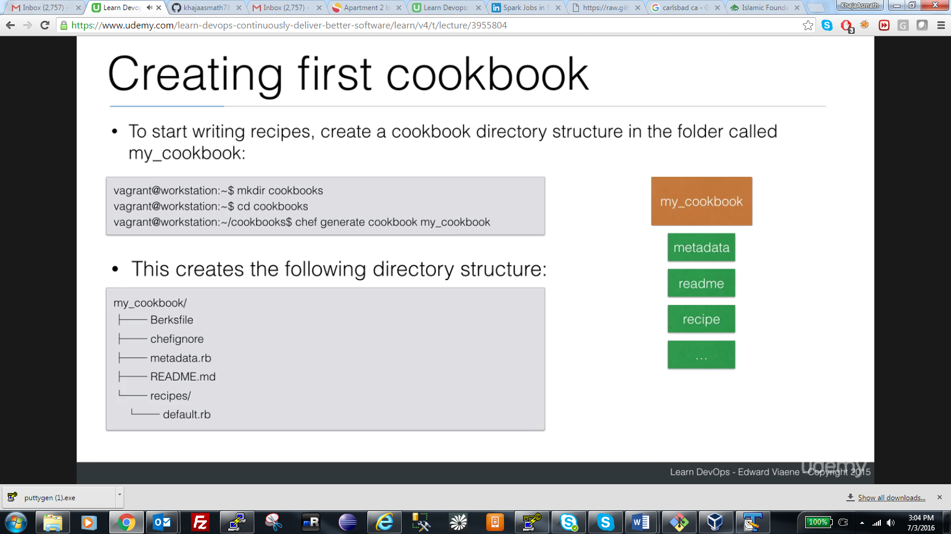

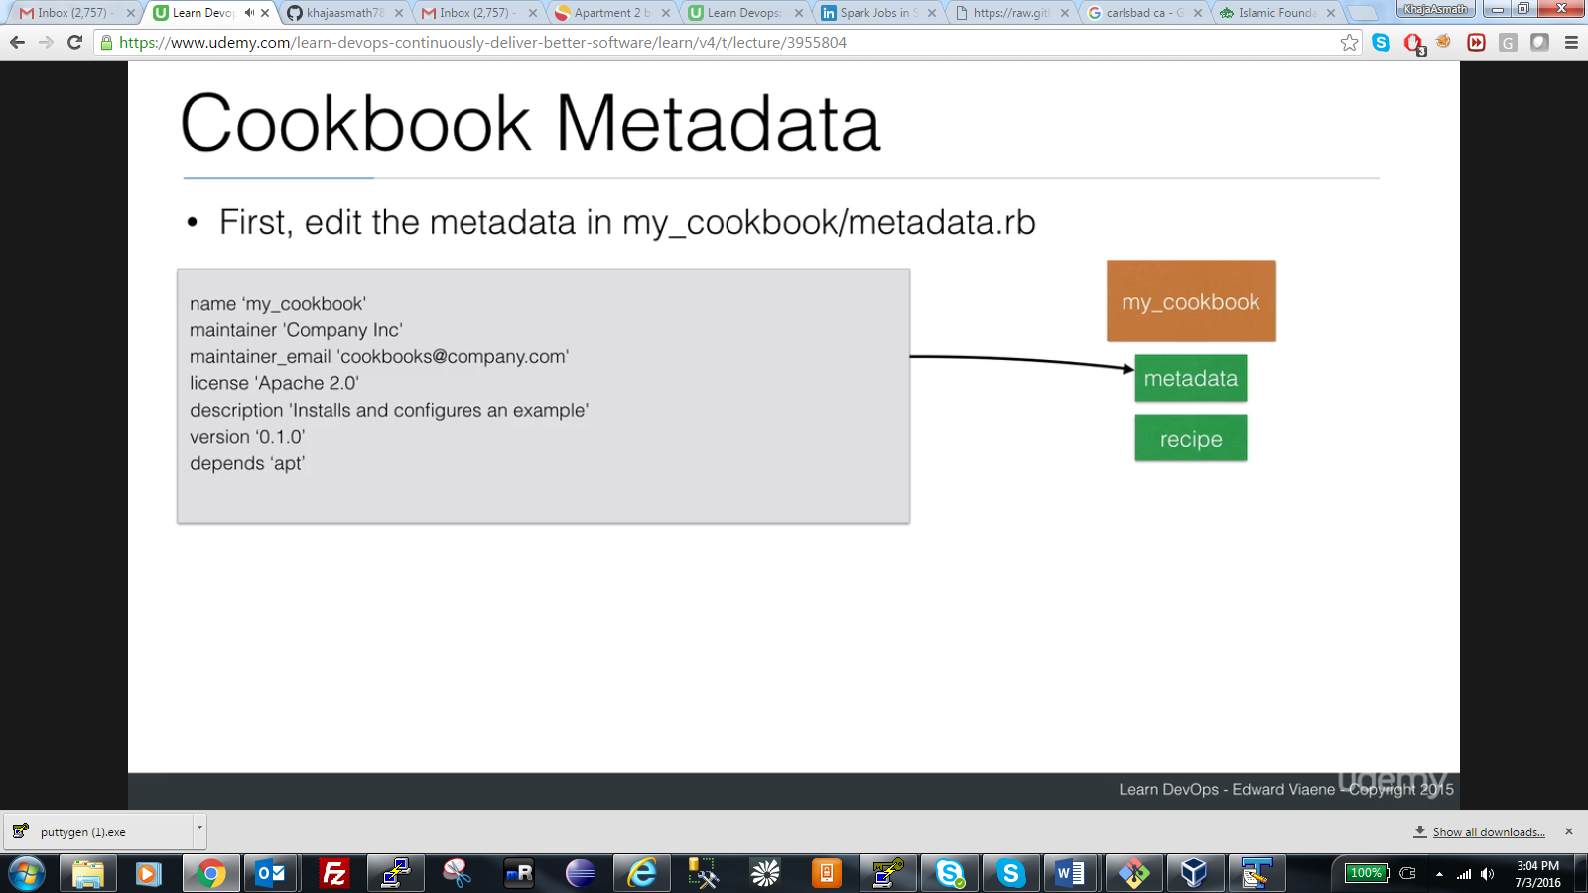

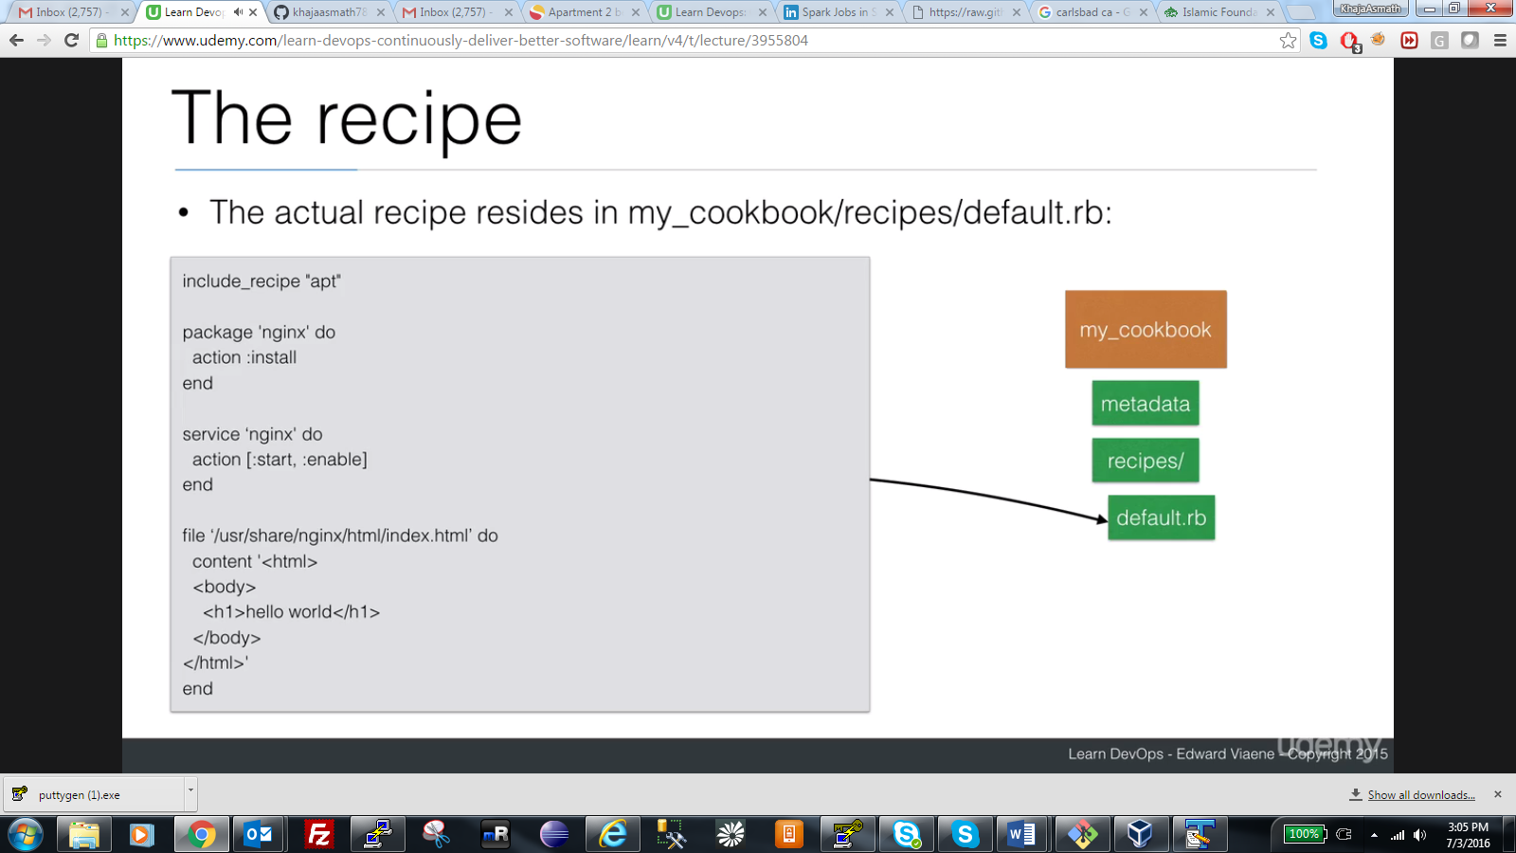

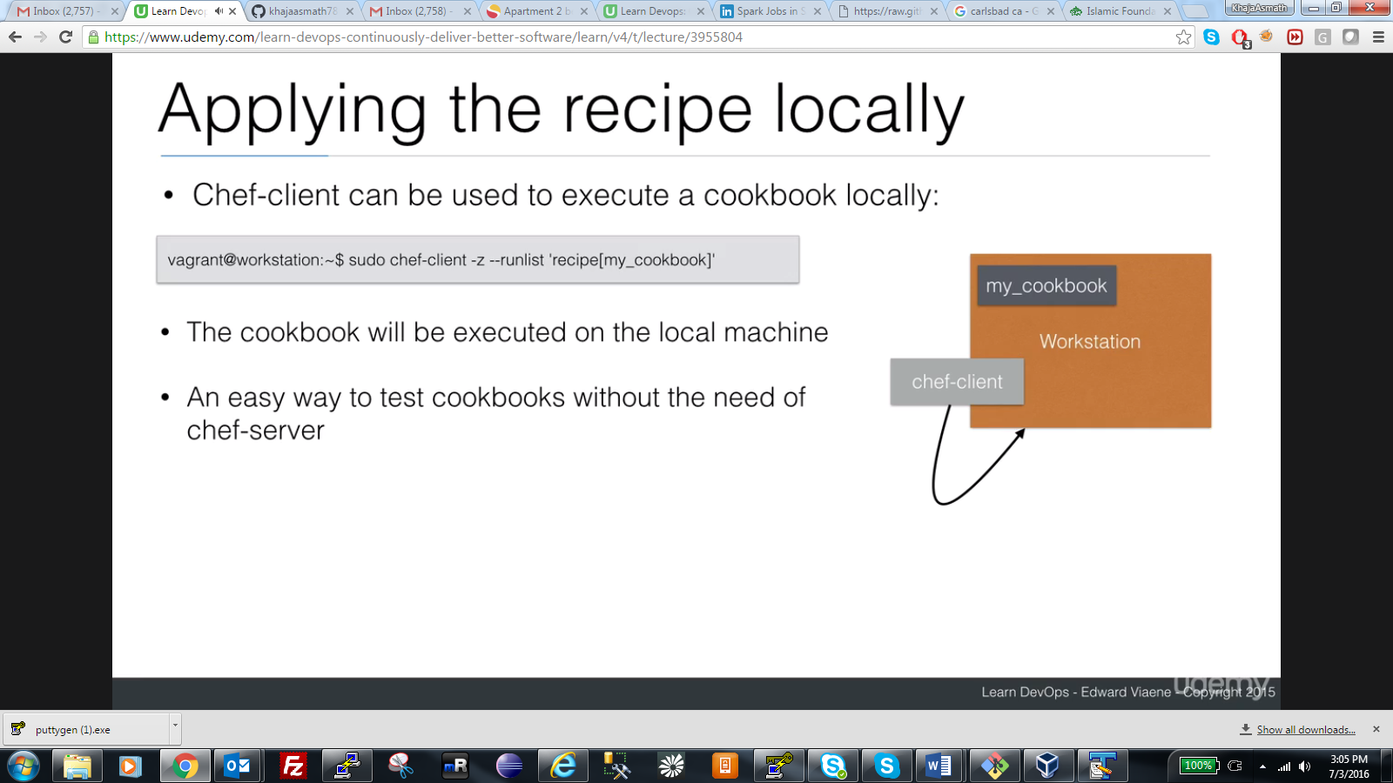

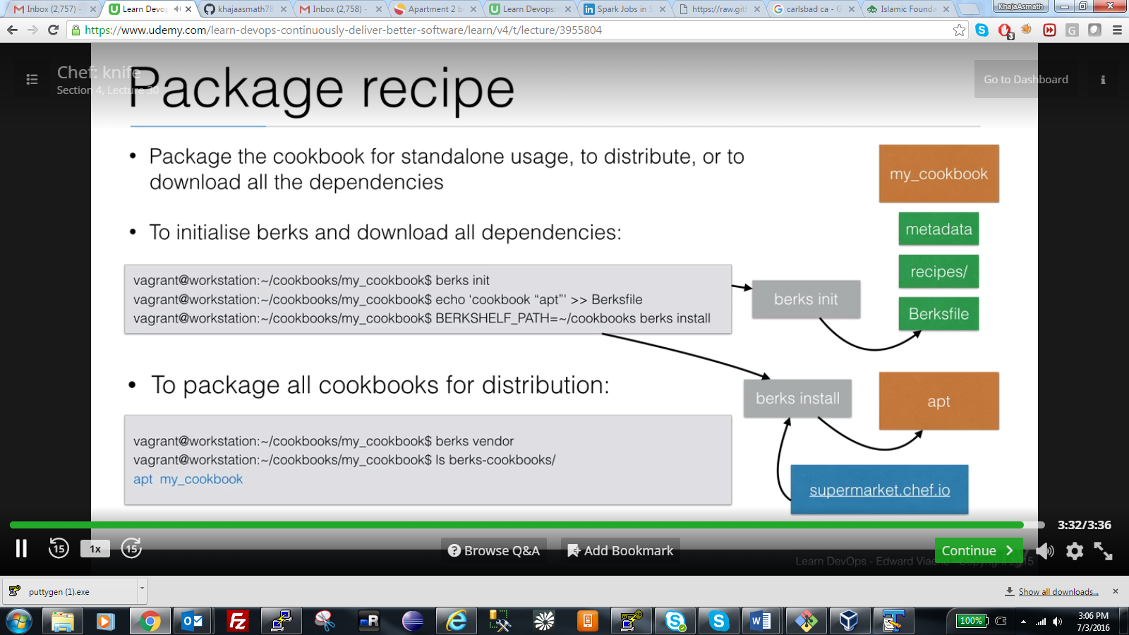

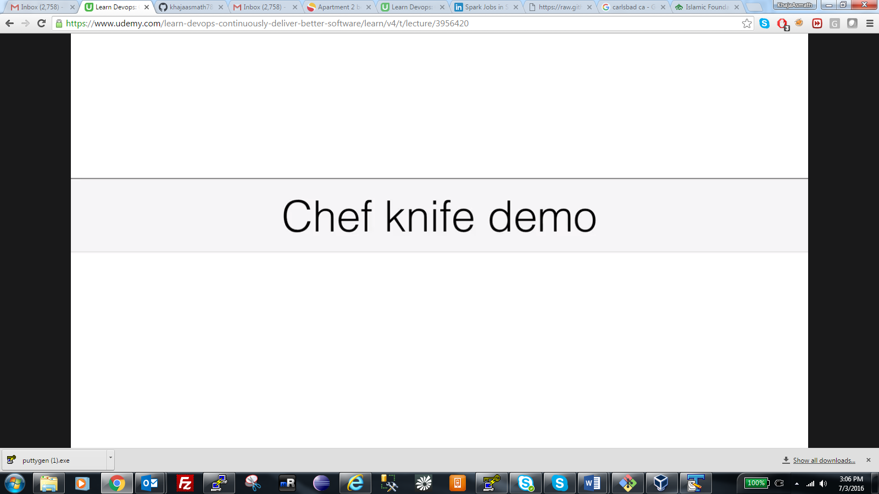

How to use chef without chef server and create work station without chef server.

* Open gitbash
* cd /home/vagrant
* sudo apt-get install git
* git clone <https://github.com/khajaasmath786/chef-demo>
* mkdir chef 🡪 change as you want.
* cd chef
* git clone <https://github.com/khajaasmath786/chef-demo>
* cp chef-demo/misc/Vagrantfile . (. Represents current folder)
* vi Vagrantfile
* vagrant up workstation
* vagrant ssh workstation
* ls /vagrant/
* cd /vagrant
* Go to <https://downloads.chef.io/chef-dk/ubuntu/>

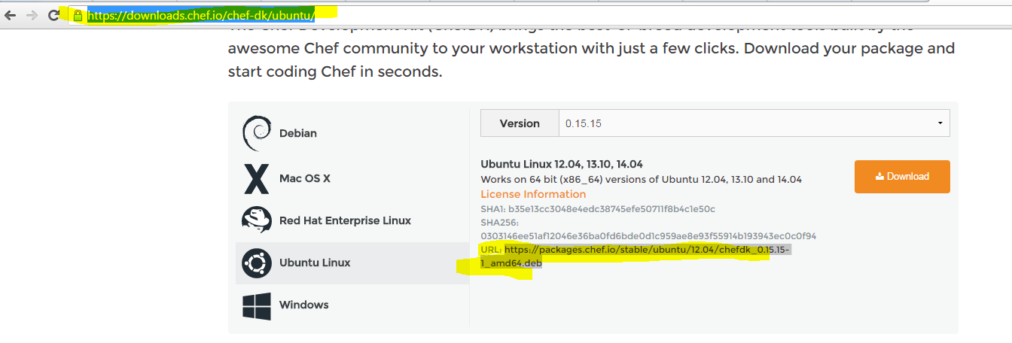

* wget <https://packages.chef.io/stable/ubuntu/12.04/chefdk_0.15.15-1_amd64.deb> (use link from the screenshot)
* sudo dpkg –i chefdk_0.15.15-1_amd64.deb
* cd ..
* sudo mkdir /home/.chef
* sudo chmod 777 .chef
* vim .chef/knife.rb 🡪 enter cookbook_path['/home/vagrant/cookbooks']and save file. If you are getting errors when running cookbooks comment this string and start running
* sudo mkdir /home/vagrant/cookbooks and sudo chmod 777 /home/vagrant/cookbooks
* cd /home/vagrant/cookbooks
* sudo chef generate cookbook my_cookbook
* cd my_cookbook
* sudo vim metadata.rb and at the end add line depends ‘apt’ 
* sudo cp /home/vagrant/chef-demo/recipes/default.rb /home/vagrant/cookbooks/my_cookbook/recipes/
* sudo vim my_cookbook/recipes/default.rb

remove text as shown below.

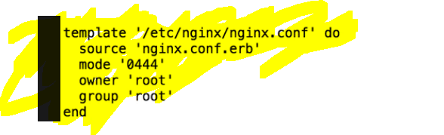

* cd /home/vagrant/cookbooks/my_cookbook
* sudo berks init (TYPE Y for all)
* sudo berks install
* ls ~/.berfshelf/cooksbooks/ (ls ~/.berkshelf/cookbooks/apt-4.0.1/)
* sudo berks vendor ( This will create all dependencies in same folder like maven )
* sudo mv berks-cookbooks/apt/ ..
* cd ..
* 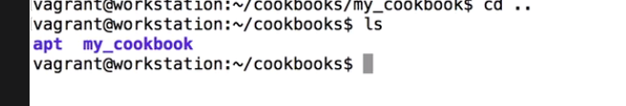
* sudo chef-client -z --runlist 'recipe[my_cookbook]'

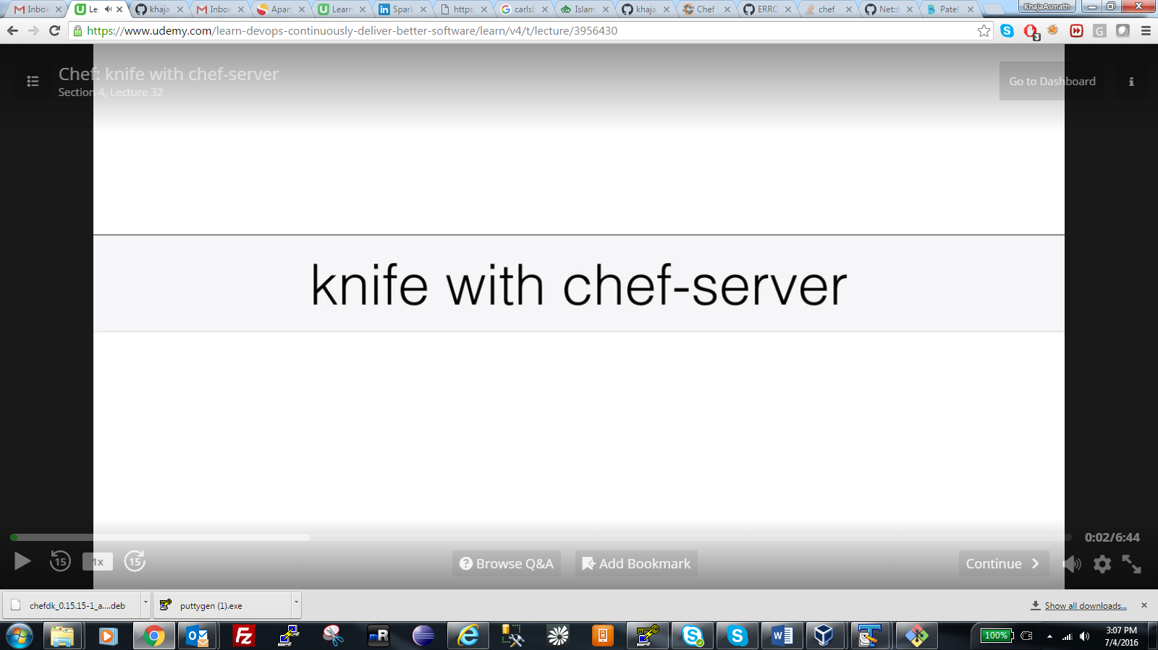

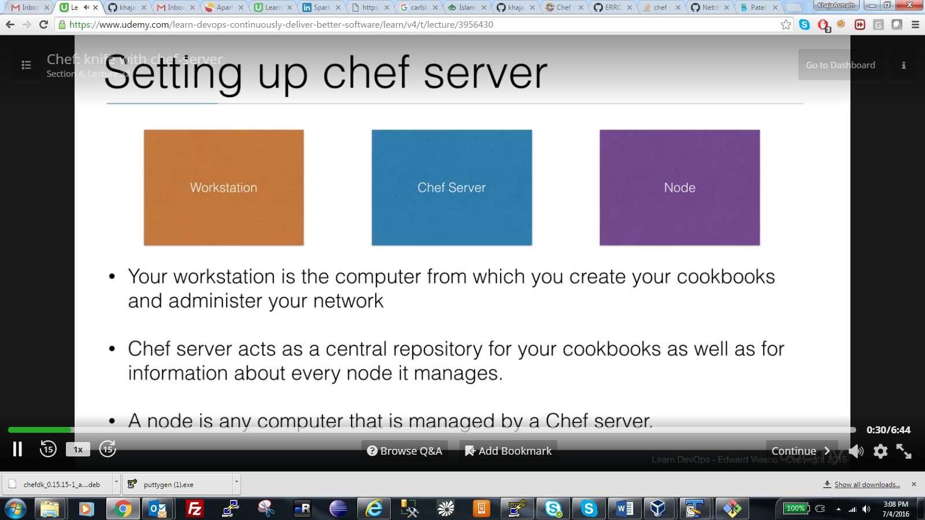

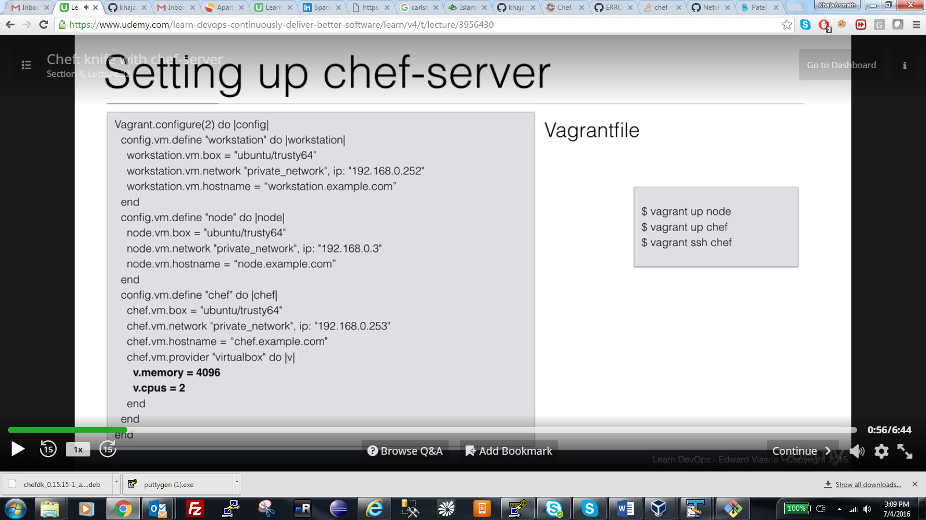

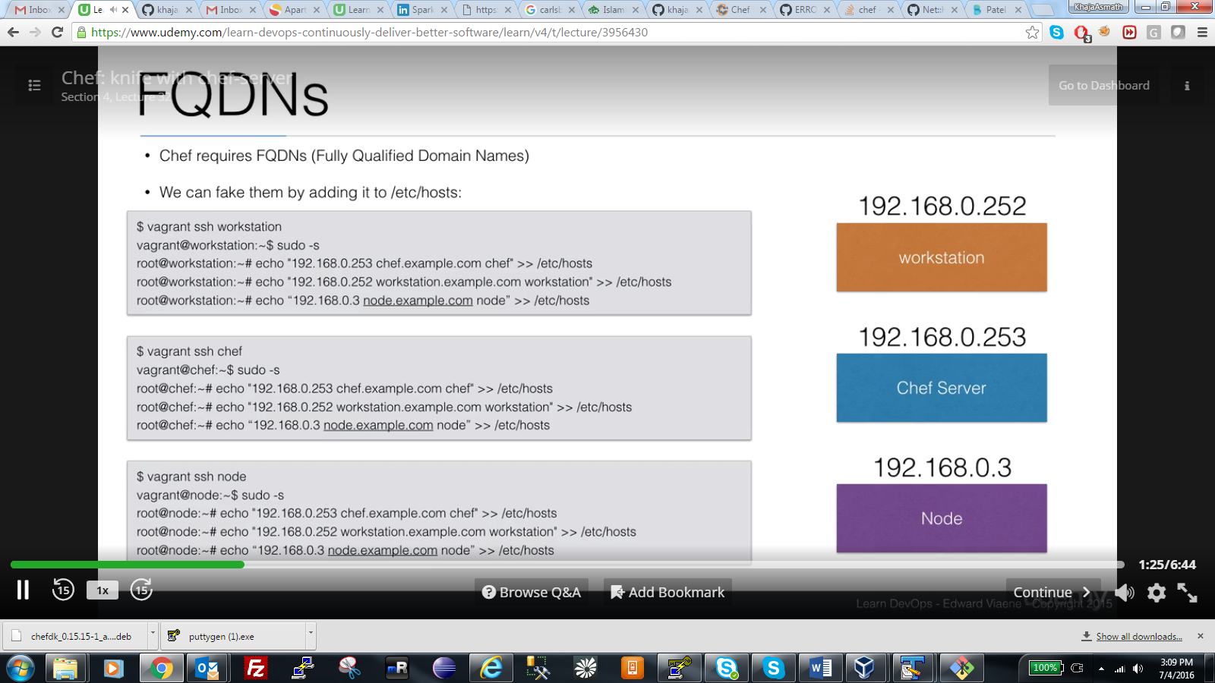

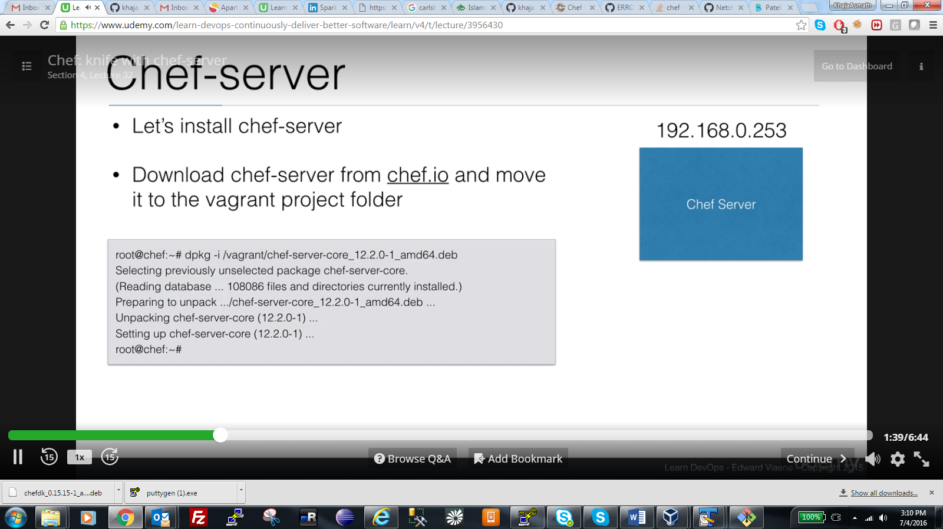

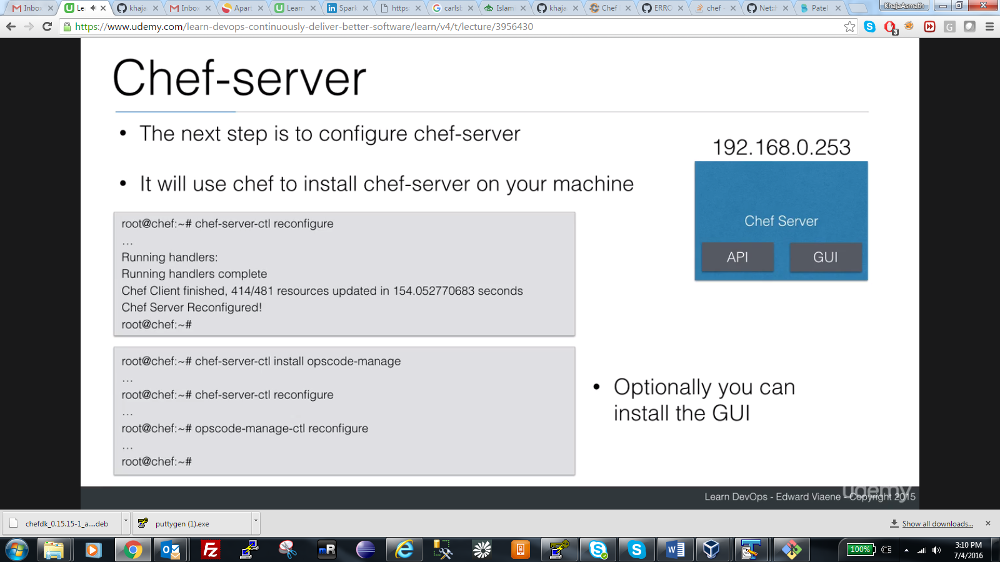

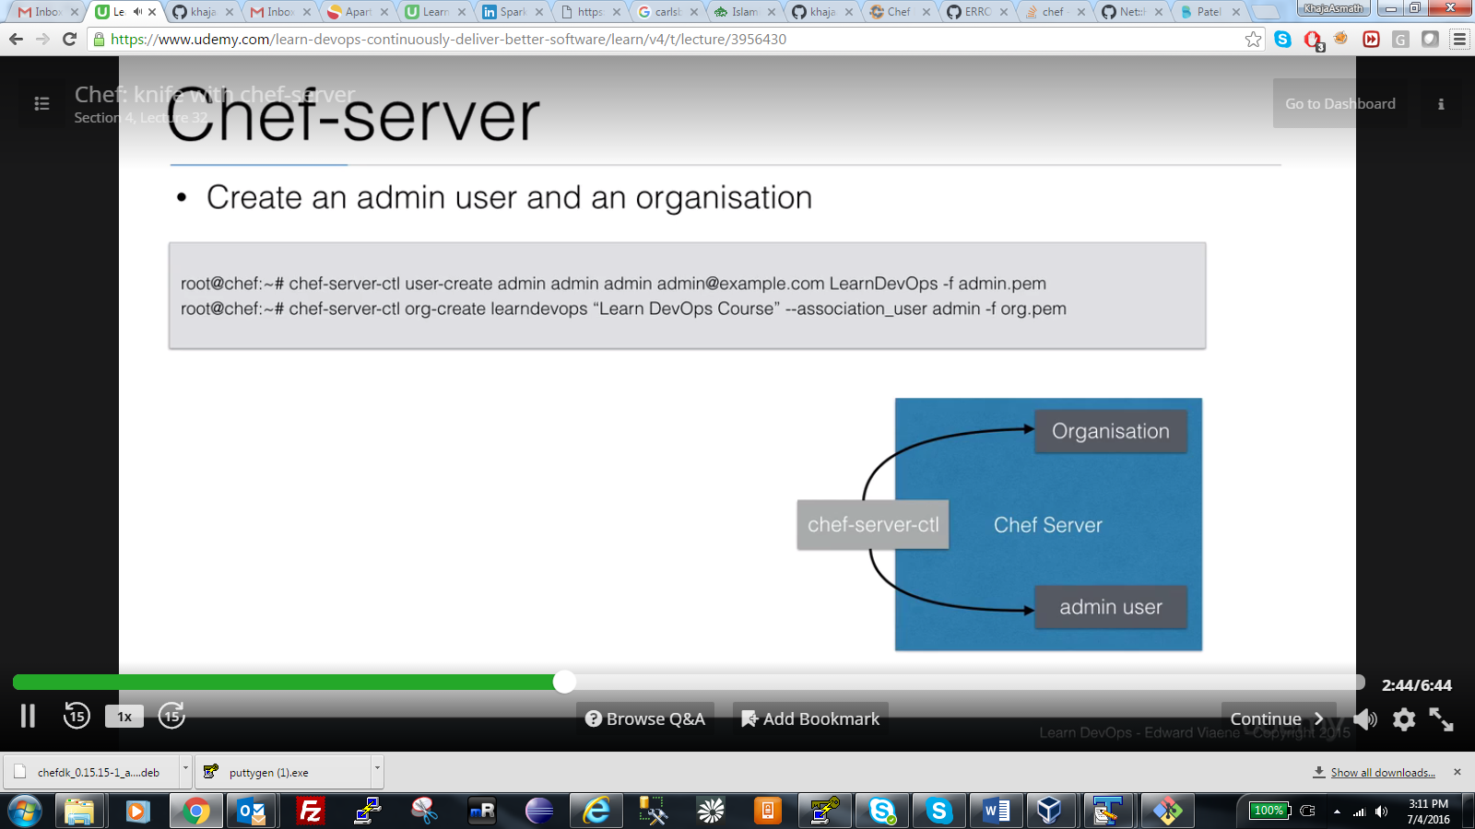

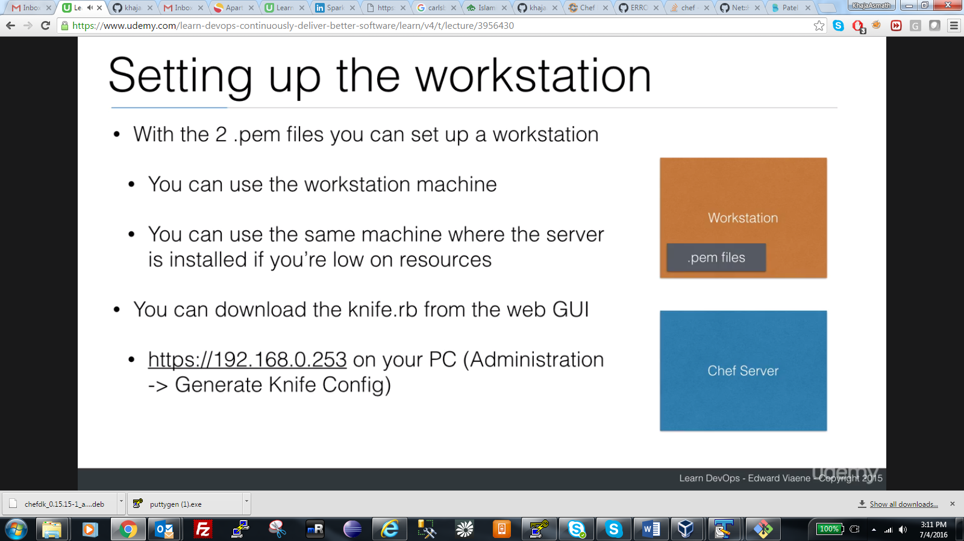

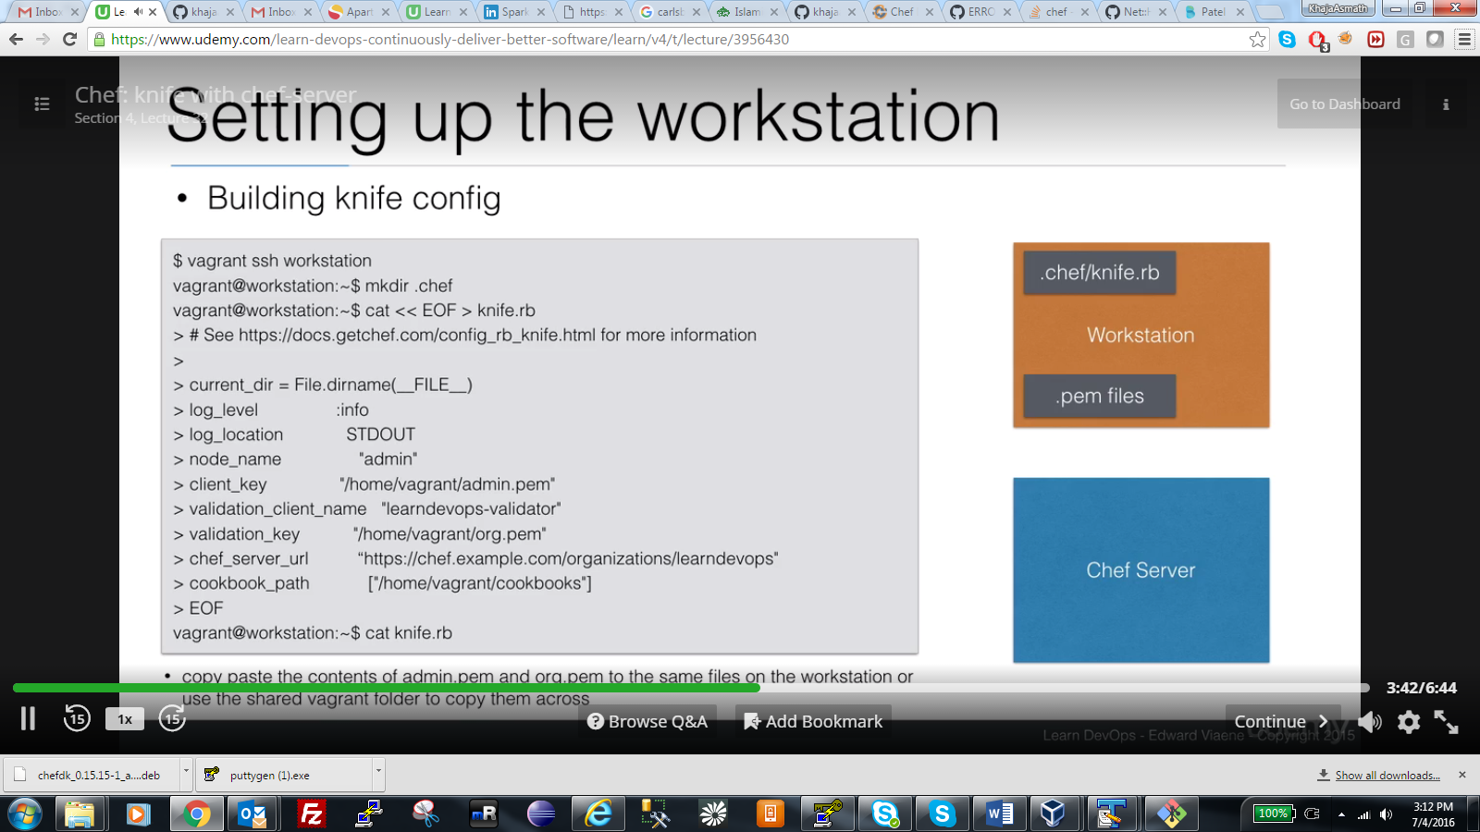

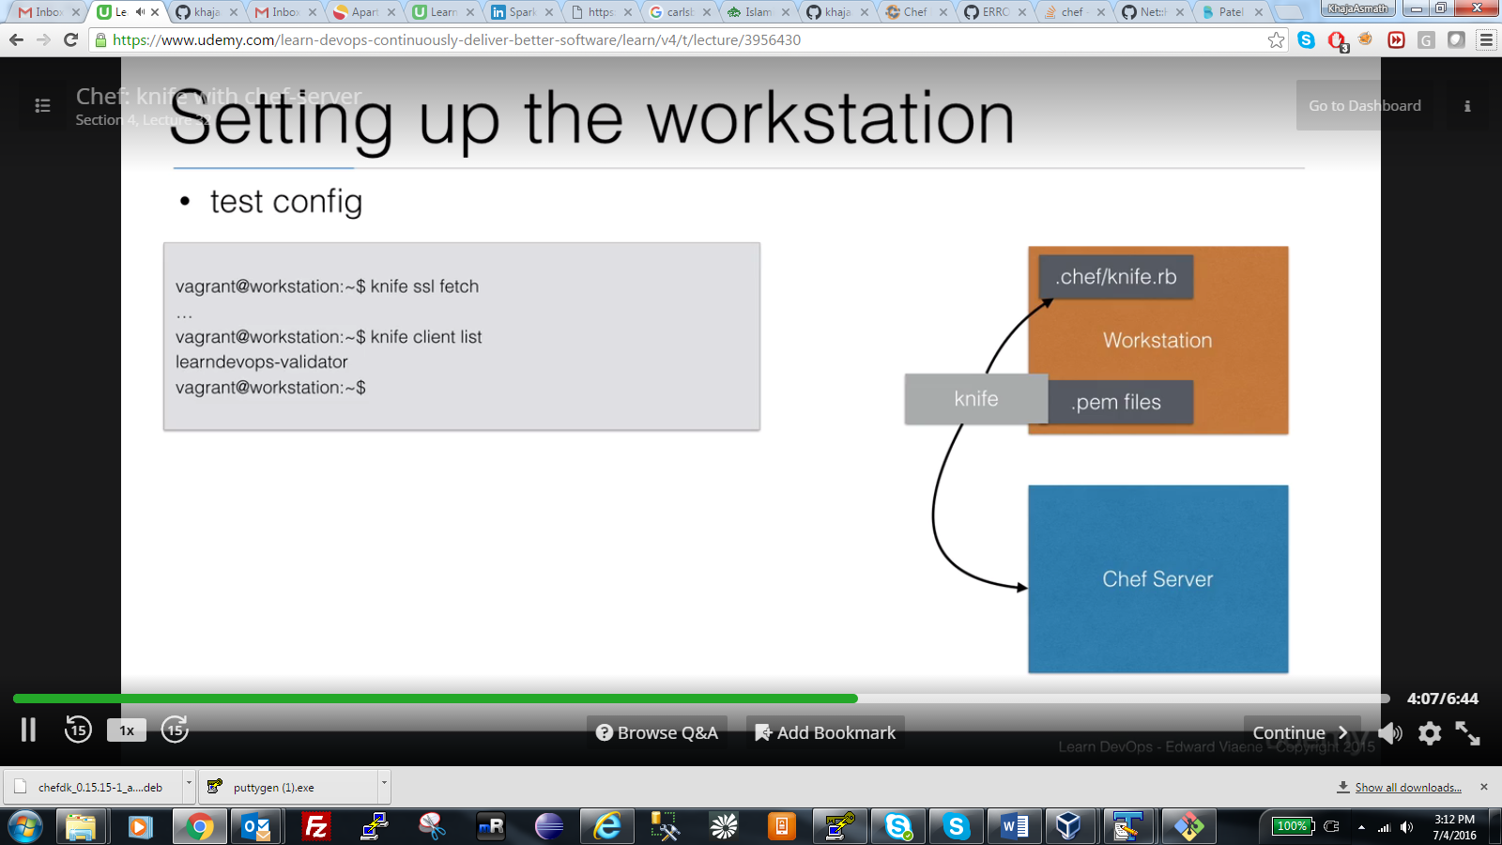

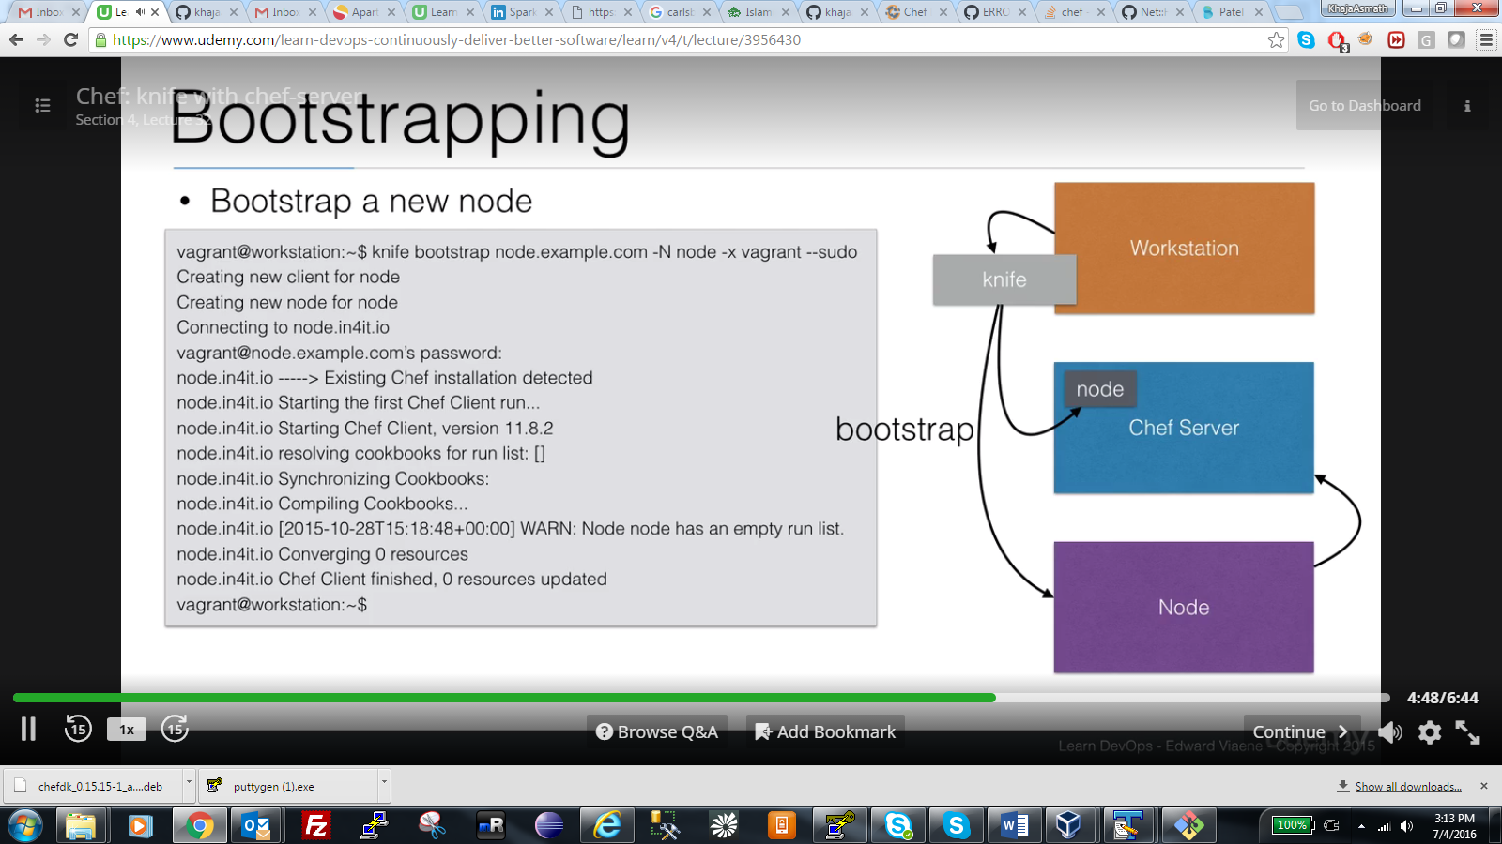

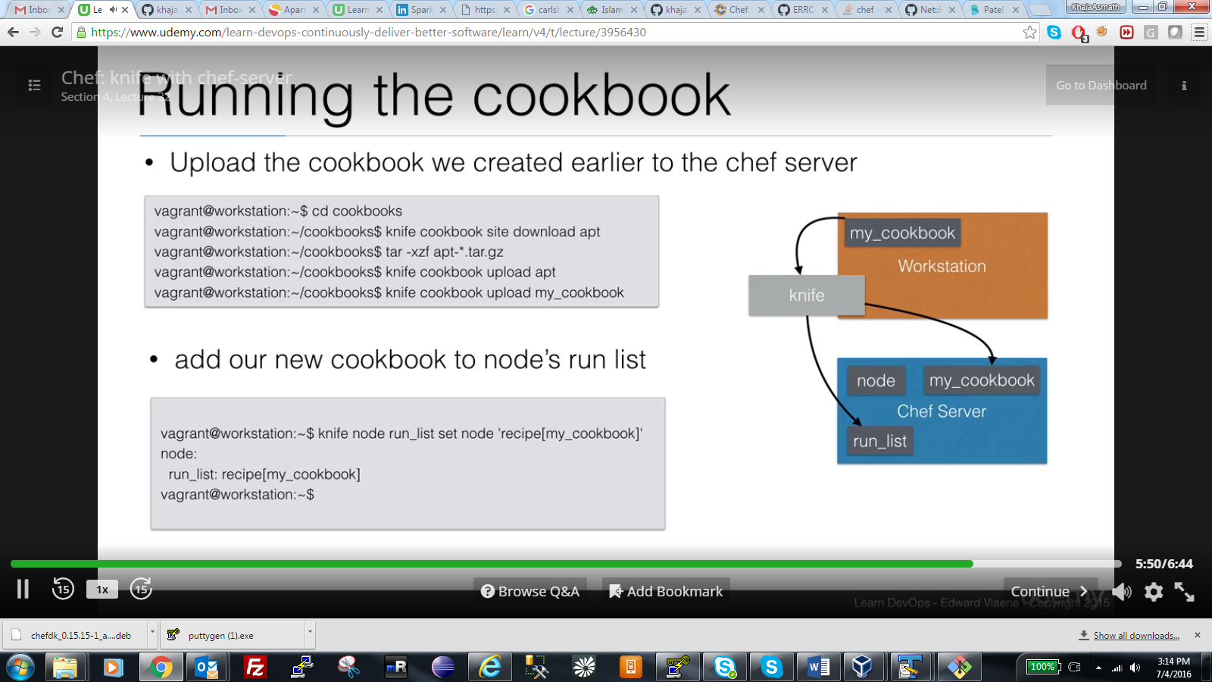

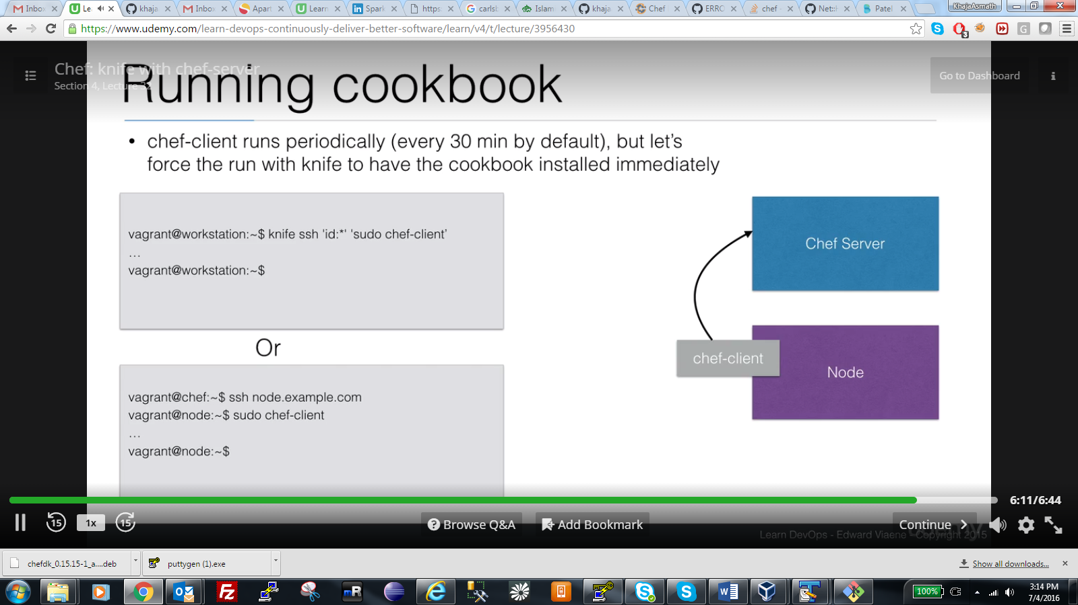

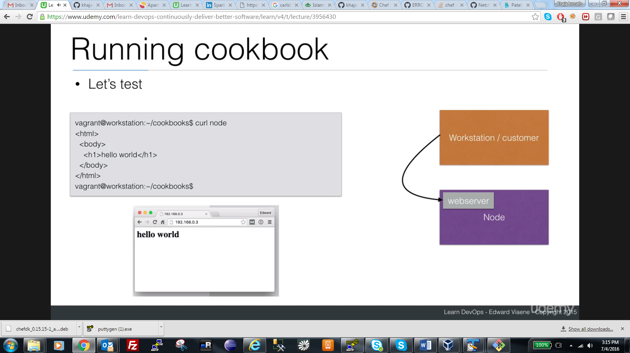

CHEF ROLES:

